1. Go to pom.xml

2. Choose your dependencies as per your requirements.

3. Now, go to maven central repository - https://mvnrepository.com/repos/central

4. Search for the dependency. For e.g. if you need to add java client dependency

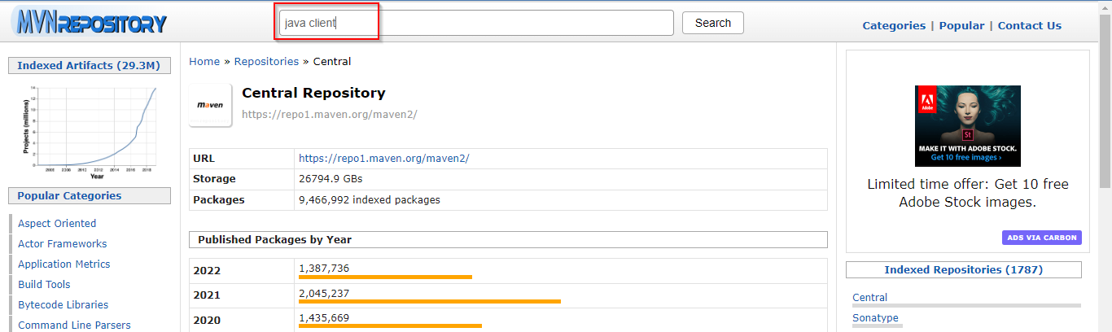

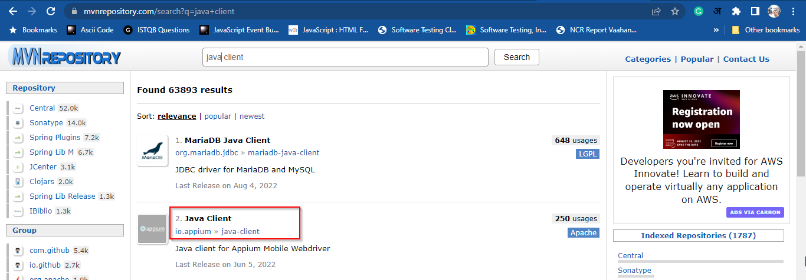

5. Select the version of the dependency

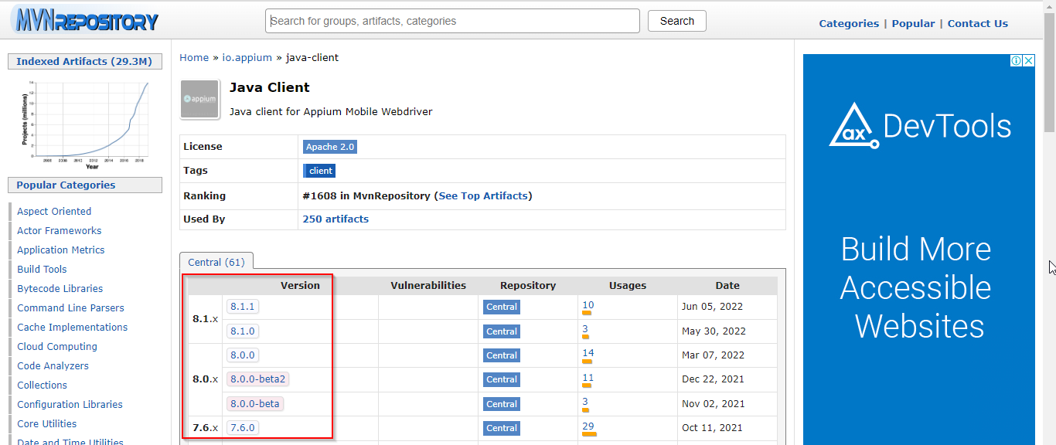

6. Now, choose your build tool type – For e.g. Maven, so, go to Maven tab

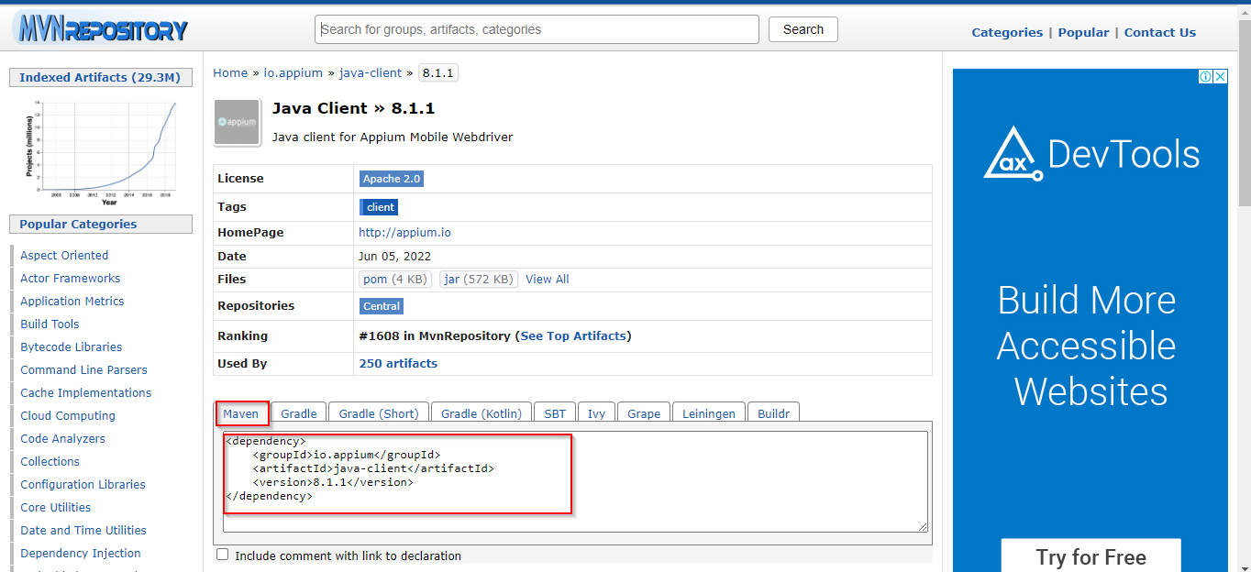

7. Copy the dependency and paste it to pom file

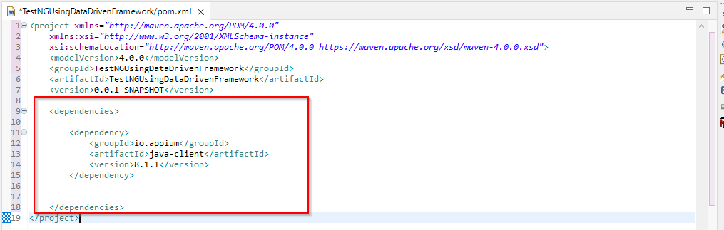

8. Now save the file and wait to build the project.

9. Go to the java class and try to access the respective function related to that dependency.